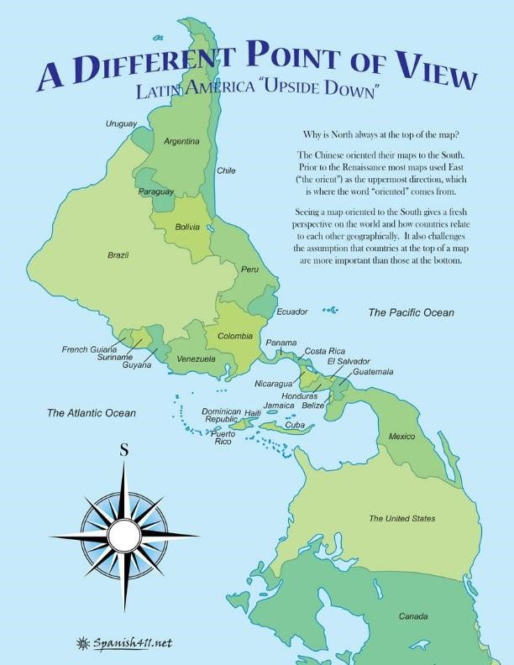
Teacher Training Workshop on Jan. 23
Morning Session
Joseph Holbrook
“A Different Point of View”
First hour:
Exercise for discussion: Project several global maps on the screen (or pass out hardcopies). Ask the participants to identify how many continents there are?
Ask them why? They must justify or defend their answer?
Is America (or the Americas) one continent? Or two?
- The Invention of America
- The indigenous names for the “American” empires
  - Anáhuac.
  - Tawatinsuyu.

- The Cruciform “Three continent map” of the world from Medieval Europe: Shem, Ham and Japeth
  - 1502 The Invention “America”; a “new” world and a “fourth” continent
  - Why America and not Amerigo? (Hint: AfricA, AsisA, EuropA)

- Discovery? or Invention? Two different Paradigms
  - Modernity: Triumphant Europe
  - Coloniality: Peruvian sociologist Anibal Quijano “coloniality is the darker side of modernity.” Modernity is enter tangled with coloniality … one cannot exist without the other.

- Who is an American?
  - Spanish and Portuguese Creoles at the time of independence began to think of themselves as “Americanos”
  - Jose Marti “Nuestro America”
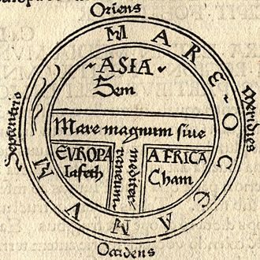
  - Are indigenous Aztecs in Mexico who barely speak Spanish Mexican? Are they Americanos? Latino Americanos? Hispanics? (meaning tracing their roots to Spain and Spanish culture and language?)
  - Are Afro-Cubans with Yoruban ancestry “Americanos”? Cubans?
  - Estadounidenses? How did they appropriate the name “American” for themselves?
In 1502 Italian explorer Amerigo Vespucci was sailing south along the coast of Brazil on a Portuguese ship when he noticed that the starts were different than what he was accustomed to in the northern hemisphere. He realized that they were sailing alongside a ‘new’ continent and named it after the feminine Latin version of his own name: America
Conclusion: The “idea of America” is a modern European invention and is limited to European’s view of the world and a European view of history. Descendants of Europeans (the Creoles) appropriated the term “Americanos” for themselves (but not for indigenes or Africans).
Definitions:
Modernity: refers to a period in world history that can be traced back either to the European Renaissance and the “discovery” of America (a view that is favored by scholars from Southern Europe: Spain, Italy or Portugal) or To the European Enlightenment (a view favored by scholars from Anglo-Saxon countries; England, Germany and Holland)
Colonialism: refers to specific historical periods of imperial domination of such powers as the Spanish, British, Dutch and the United States in the twentieth century.
Coloniality: refers to the “logical structure of colonial domination underlying the Spanish, Dutch, British and U.S. control of the Atlantic economy and politics, and by extension, control of the entire planet. Coloiality is the logic of domination in the modern/colonial world.
Modern technology, alongside political and economic restructuring in the second half of the twentieth century made it unnecessary to colonize in the old, more obvious manner. Nevertheless, the U.S. still does maintain military bases in the Middle East, Asia and South America
America was not “discovered,” it was not “conquered,” it was invented.
The shift in 9-11, even liberals recognized the necessity of maintaining imperialism in some form = “imperialism lite”
Racism: the hegemonic discourse of that questions the humanity of those who do not belong to the hegemonic group, or those who assign the standards of classification and assign to themselves the right to classify the outsider groups.
Conclusion: The “idea of America” is a modern European invention and is limited to European’s view of the world and a European view of history.

PART 2 – THE INVENTION OF “LATIN” AMERICA
Exercise for discussion: What is the difference between the terms “Hispanic” or “Latino”? who is a Latino and who is a Hispanic?

– set in the nineteenth century in the era of Spain’s decline and the growing power of the United States
First coined by writers and intellectuals in Colombia and Mexico as an alternative identity to Anglo-Saxon, Protestant America
It represented an attempt to incorporate French heritage (Catholic and Monarchical) as part of Spanish American heritage and identity
With the invention of “LATIN” America, the American continent became two continents instead of one. A “Latin” and Catholic continent in the South, and an Anglo-Saxon and Protestant continent in the North.
Porfirio Diaz on Mexico: “Pobre de México, tan cerquita a los estados unidos y tan lejos de Dios.”

Globally, there were now 5 continents instead of three.
Today, there is a debate about whether there are seven continents or Europe and Asia should be combined into one super continent, EURASIA.
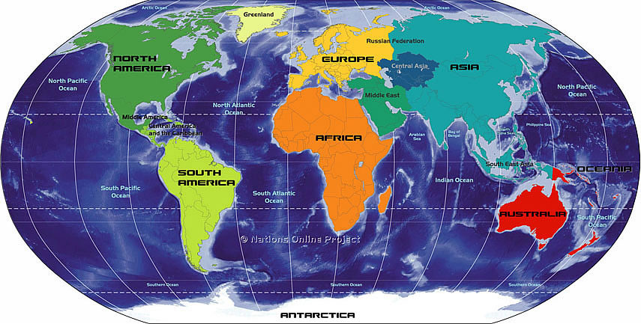

The Age of Revolutions (Pachacuti)
Traditionally, the age of Revolutions is considered to be from 1776 through the end of the Spanish Wars of Independence that ended in the 1830s. However, it is possible to view the founding of the modern world as a series of upheavals, convulsions and revolutions going back to the Glorious Revolution (1688) in Great Britain, the Protestant Reformation in 1517 (a type of German Revolution against Rome?) and all the way to the arrival of the Europeans in the Bahamas with Christopher Columbus. For the native inhabitants the European arrival was a “Pachacuti” … Kuti means a sudden and dramatic change in the order of things, and Pacha means world. Mignolo calls this the “founding colonial wound of the modern/colonial world.” (p.53)
The emergence of Latinidad
- By the middle of the nineteenth century, the idea of America as a whole began to be sub-divided into north and south, Anglo and Latin (p.57).
In the Iberian ex-colonies, the idea of Latin America emerged as a consequence of conflicts between imperial nations
This “idea” was needed by France to justify its conflict with the U.S. for influence in the South of the Americas.
It was also needed by creole elites in Spanish America to defend their identity against the growing hegemonic threat of Anglo America.
Latin America is not so much a sub-continent as it was a political project; it simultaneously lifted up the Spanish creole elites and erased the identities of the Indian and African populations (who were not Latino).
1856: Colombian intellectual Jose Maria Torres Caicido used the phrase Latin America in a poem “Two Americas.”
The term was used the same year in Paris at a conference by a Chilean Francisco Bilbao.
The term was further supported in the French empire of Napoleon III during the French invasion of Mexico. French intellectuals used the term to try to rally solidarity among the nations of South America with France in order to confront the expansion of the United States south and westward.
Spain “missed the train” of modernity and was in economic and political decline and Creole elites looked instead to France as the idea in politics and literary culture.

In the same way that John Locke, David Hume and Thomas Hobbes influenced political culture in the United States, Jean-Jacques Rousseau, Voltaire and Montesquieu became the principle sources of political culture in the former Spanish countries (and Brazil) to the south; “Latin” America.
“Independence, in all the Americas including the U.S., ended external colonialism and replaced it with internal colonialism.” (p.68) the creole elite in America and Haiti replaced the British, Spanish, Portuguese and French elites in the driver’s seat.
Dependency did not vanish, it was restructured. This is the difference between colonialism and coloniality
Bilbao was critical of European, U.S. and Russian imperial ambitions and particularly focused on the French advances in Mexico and French attempts to control “Latin” America. Spain was already out of the picture and Great Britain was focusing on Asia and Africa.
1856, in Iniciativas de la America (p.69)

