Climate Change: Original Painting

by
Student Name
HSA4113 – Online – Semester
Global Issues and Trends in Healthcare
Professor

Florida International University
Month, Day, Year
Climate Change: Original Painting

Andrea Juan
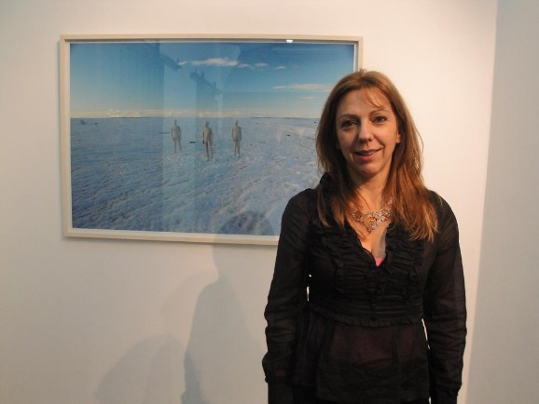

For the past decade Juan, who is a professor of visual art at the National University of Tres de Febrero in Buenos Aires, has been journeying to Antarctica for month long periods to stage installations and performances across the empty continent. Though inspired by gloomy statistics, her work does not convey horrible notions of environmental disaster, and it's not over baring with ecological nostalgia, the vibrant material even has an undeniable joyful quality to them. When Argentinian artist Andrea Juan learned that the ice shelves of the Weddell Sea of the Antarctic coastline were melting, exposing the rare paleo botanical species that have lived there undisturbed for the past millennium, she leapt into action as only an artist can. Creating defensive looking sculptural creatures out of bundles of felt much larger and brighter than the animals inhabiting the disappearing sea floor along with bundles of tulle formed into psychedelic forms of toxic gasses, Juan arranged these across the ice's surface to draw attention to the ecological tragedy underway.
It is a lyrical gesture typical of the 50-year-old artist's work, which frequently extracts fact values from the hard and dry facts of scientific investigation. Since travelling to Antarctica for the first time in 2004, Juan has focused on the impact of climate change in Antarctic and its position as the driver of the entire planet’s weather and ocean systems biology. Not only has she traveled to the cold country she also pioneered Global Warming actions in her native Argentina. Gaining attention of the government on how the climate is currently affecting the country and persuading for a change. The immense and potentially changes foreshadowed by scientific enquiry have prompted her decade long commitment to other countries (Clark, 2016).
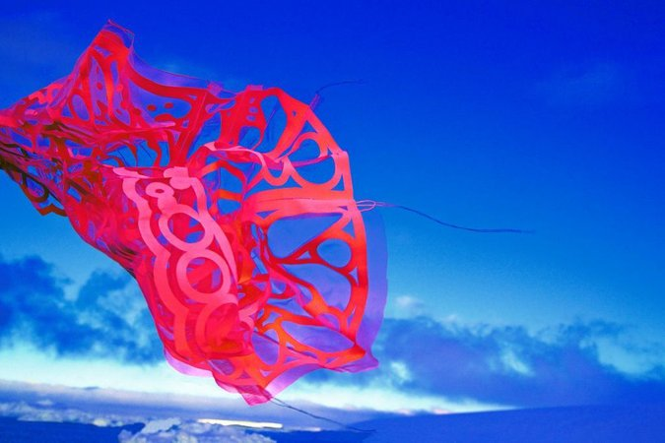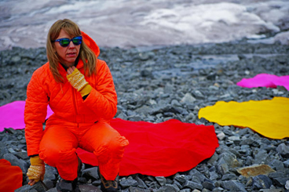

Ashley Cecil

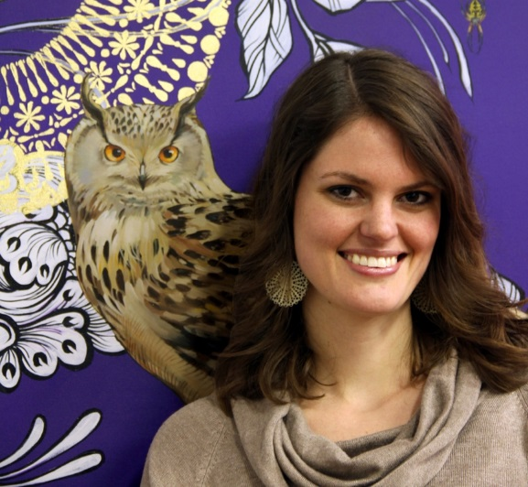

Ashley is a Pittsburgh-based artist and illustrator specializing in hyper realistically rendered paintings of flora and fauna. Her clients include universities, Fortune 500 Companies, national nonprofits and private collectors. Her pieces lead her to developing an interest in the climate and its ongoing changes that has caused in the planet. Cecil love for nature has made her create paintings that are one of a kind, Ashley entered a contest that rocketed her carrier to the top. After requesting and reviewing proposals from several emerging artists from all over the nation, Oxfam America selected Ashley Cecil, who is a self-described painting activist to create a work that would illustrate how climate change affects poor communities, Cecil's gorgeous painting of two women in a drought baked landscape depicts one of them tipping out a bowl of dust instead of a bounty of grain, symbolizing the struggle of impoverished families to feed themselves in a world facing more and more climate-related impacts.
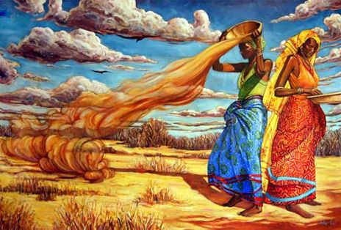

She wanted to show that the women are not harvesting crops the way they had hoped for. Which is a sad reality that many countries are currently dealing with (Urbschat, 2016).

Original Drawing/ Painting
After my intensive research on artists that were inspired by the climate change, I created a portrait myself that conveys my interpretation of the ongoing climate change affects to the planet and the countries in it. A large portion of my inspiration was Andrea Juan, her artwork and sculptures filled with colors automatically caught my attention, and that is what I was trying to accomplish with my piece. Grabbing the attention of the population will be the only way to convey a message. It needed to be entertaining yet modern so I went towards the direction of graffiti and pop art.
My piece is basically a planet that is melting due to the horrible heat that is affecting the world at this moment, I placed the sun around the entire planet to interpret that no matter where in the world you go the heat is still unbearable from locally here in Miami to across the ocean in China. My piece will catch the attention of a young hipster that likes art and graffiti to an older more sophisticated person that will wonder what is the meaning behind the drawing. I feel like I accomplished my purpose in grabbing the attention of my audience and conveying an important message. I started thinking on where I can demonstrate and display my art piece and the first place that came to mind is my job.
I am currently working with a doctor that specializes in Internal medicine and pulmonary Medicine in Miami. A beautiful city but filled with pollution and toxic air due to the overgrowing population. On Thursday morning before we started with our patients I placed my drawing in the first room were the patients first enters. I decided to make it interesting and purposely not place any label or caption on my piece, this way ill have the patients wondering on why that drawing is there. While I was taking a patients vital, the first patient asked me what’s the significance behind that drawing so I graciously explained to him about the horrible climate change that is affecting many countries. I put the drawing in every room I went into and about 85% of the patients asked me about the drawing, which shows that it is grabbing the attention of my audience. It was interesting seeing the reaction of the patients after they saw a random drawing in the room but after explaining to them they understood why it was there.

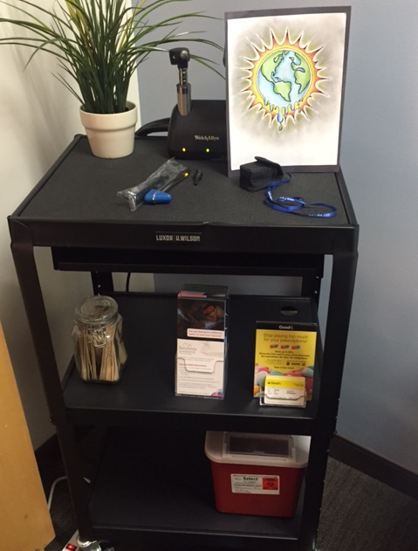

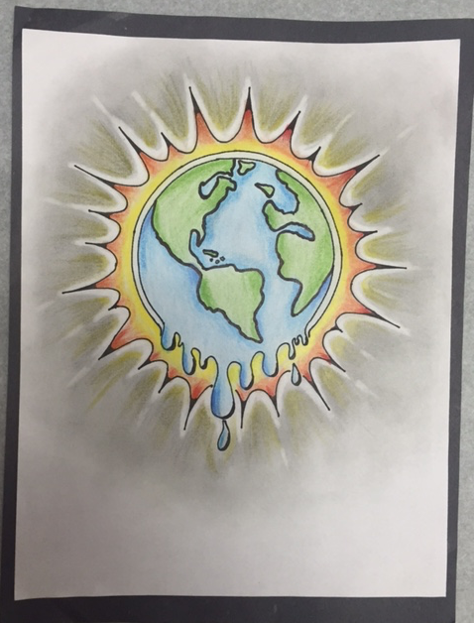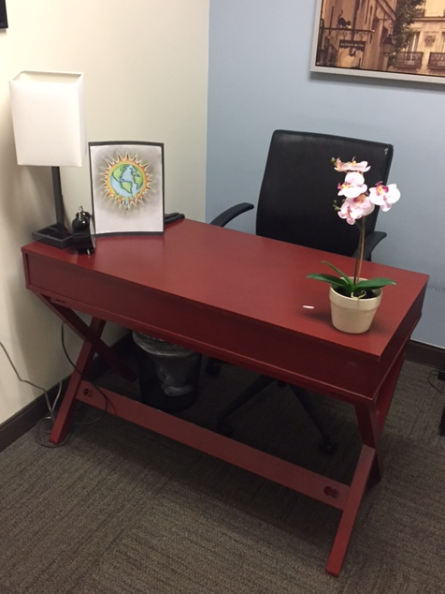

References
Clark, T. (n.d.). Trish Clark Gallery. Retrieved July 17, 2016, from http://trishclark.co.nz/artists/juan-andrea/

Urbschat, L. (2014, December 17). Only in Pittsburgh: The new work of artist Ashley Cecil. Retrieved July 17, 2016, from http://www.popcitymedia.com/features/cecilfeature_121714.aspx

