**ANTHROPOLOGY RECORDING FORM**

**INDIVIDUAL ADULT SKELETON**

**CASE NUMBER:**

**Case Start date/time:**

**Case end date/time:**

|  |  |  |
| --- | --- | --- |
|  | **Name** | **Signature** |
| **Anthropologist** |  |  |
| **Checked by** |  |  |
| **Database Entry by** |  |  |
| **Reviewer 1** |  |  |
| **Reviewer 2** |  |  |

**SEX DETERMINATION**

**Pelvis**

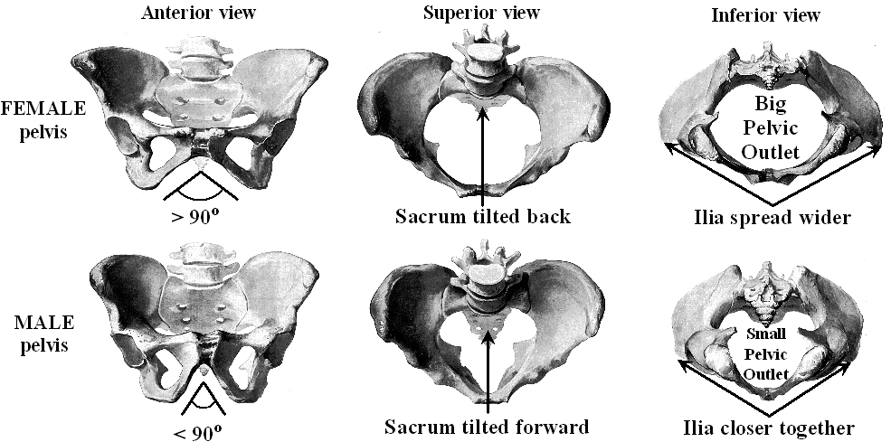

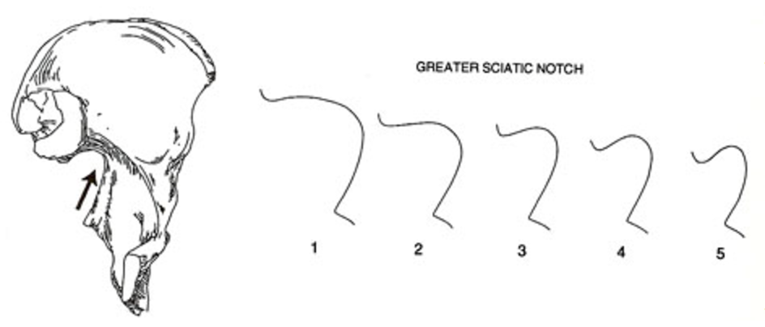

|  |
| --- |
| **Circle the Appropriate Answer** |
| **Angle** > 90 degrees   or   < 90 degrees |
| **Pelvic Outlet** Small   or   Large |
| **Ilia** Close   or   Spread |
| **Greater Sciatic Notch** 1 2 3 4 5 |

**Presumptive Sex according to the Pelvis: ___________**

**SEX DETERMINATION**

**Skull**

|  |  |  |
| --- | --- | --- |
| **Landmarks** | **Female** | **Male** |
| **Chin** | **Rounded** | **Square** |
| **Mastoid Process (Behind Ear)** | **Small** | **Large** |
| **External Occipital Protuberance (Back of Skull)** | **Small (Not Prominent)** | **Large (Prominent)** |
| **General Anatomy** | **Gracile (i.e., Graceful)** | **Robust** |
| **Forehead** | **Vertical** | **Receding (Careful with the comments . .)** |
| **Brow Ridges (Location of Eyebrows)** | **Slightly Developed** | **Prominent** |
| **Muscle Lines** | **Slightly Developed** | **Prominent** |
| **Orbital Margins (Edge of Eye Socket)** | **Sharp** | **Rounded** |

|  |
| --- |
| **Circle the Appropriate Answer** |
| **Chin** Rounded   or   Square |
| **Mastoid Process** Small   or   Large |
| **Occipital Protuberance** Small   or   Large |
| **General Anatomy** Gracile   or   Robust |
| **Forehead** Vertical   or   Receding |
| **Brow Ridges** Slight   or   Prominent |
| **Muscle Lines** Slight   or   Prominent |
| **Orbital Margins** Sharp   or   Rounded |

**Presumptive Sex according to the Skull: ___________**

**ANCESTRY ESTIMATION**

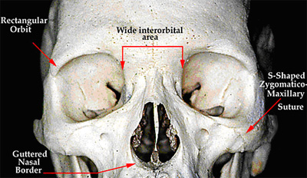**Skull**

**African Ancestry**

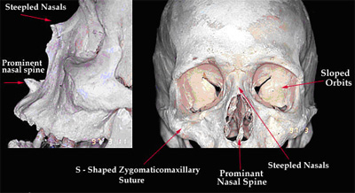

**Caucasian Ancestry**

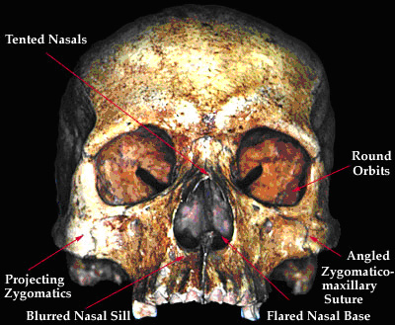

**Asian Ancestry**

|  |
| --- |
| **Circle the Appropriate Answer** |
| **Interorbital Area** Wide or Narrow |
| **Orbit** Rectangular, Sloped or Tented |
| **Zygomatic** S-shaped or Angled |
| **Nasal Spine** Prominent or Flared |
| **Nasals** Tented or Steepled |

**Presumptive Ancestry according to the Skull: ___________**

**AGE ESTIMATION**

**Pelvis**

**Pubic Symphysis**

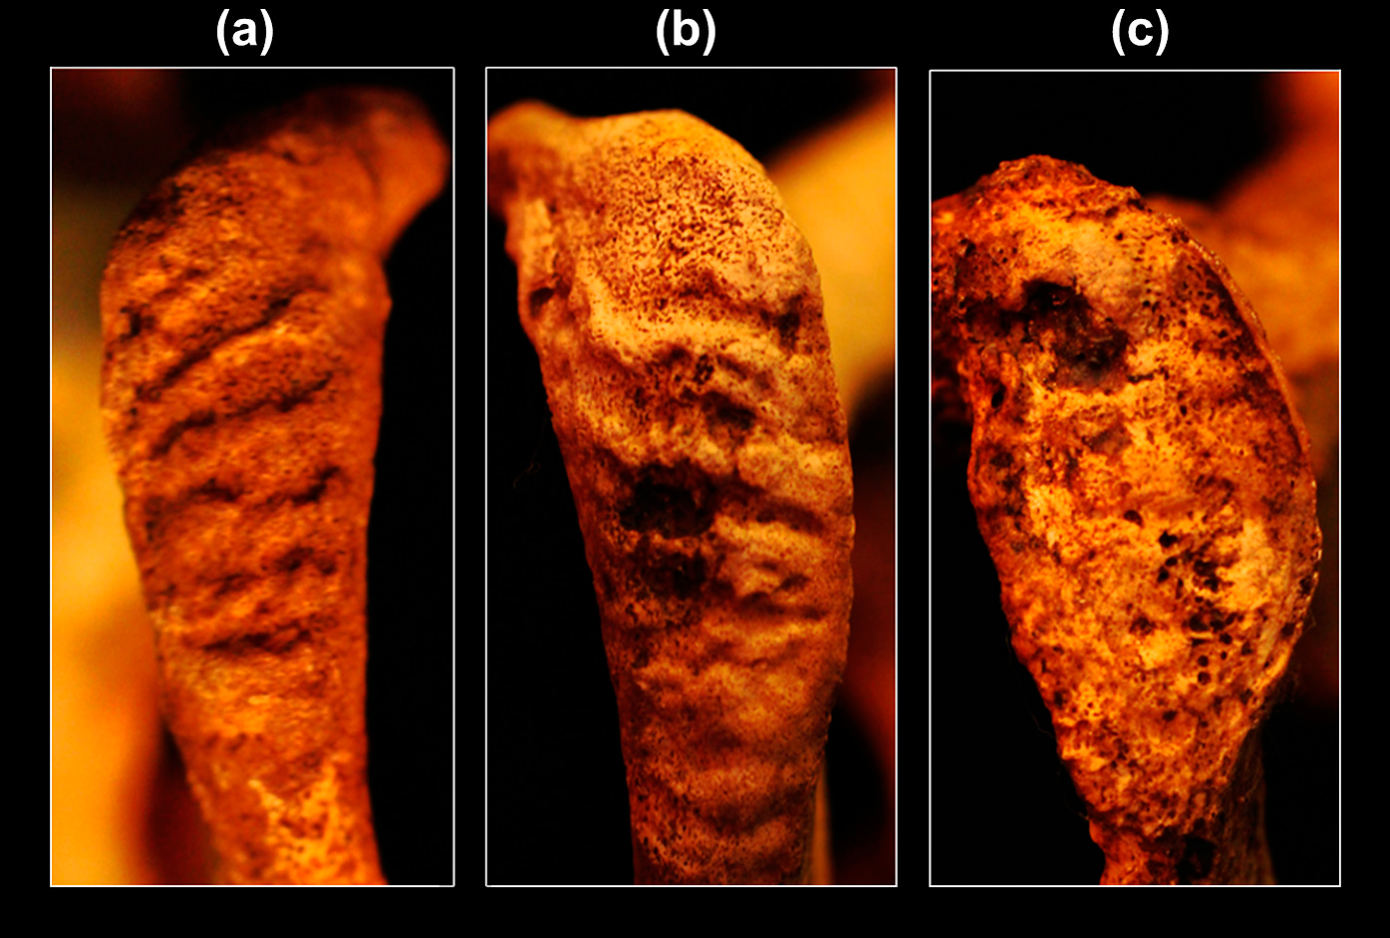

**1 Young 2 Middle Age 3 Old**

**Auricular Surface**

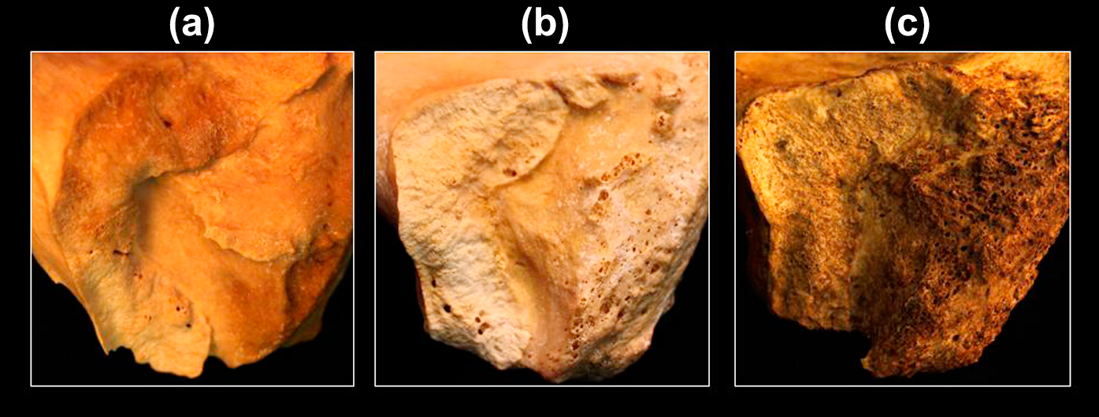

**1 Young 2 Middle Age 3 Old**

|  |  |  |
| --- | --- | --- |
|  | **Right** | **Left** |
| **Pubic Symphysis** |  |  |
| **Auricular Surface** |  |  |

**Presumptive Age according to the Pelvis: ___________**

**STATURE ESTIMATION**

**Femur**

|  |  |  |  |
| --- | --- | --- | --- |
| **Males** | **Formula** | **Stature** | **SE +/-** |
| **Caucasian** | **____ (cm) x 2.38 + 61.41=** |  | **3.27** |
| **African** | **____ (cm) x 2.11 + 70.35=** |  | **3.94** |

|  |  |  |  |
| --- | --- | --- | --- |
| **Females** | **Formula** | **Stature** | **SE +/-** |
| **Caucasian** | **____ (cm) x 2.47 + 54.74=** |  | **3.72** |
| **African** | **____ (cm) x 2.28 + 59.76=** |  | **3.41** |

**Presumptive Stature according to the Femur: ___________**

**SUMMARY**

**Sex Estimation:**

**Ancestry Estimation:**

**Age Estimation:**

**Stature Estimation:**

**Case Start date/time:**

**Case end date/time:**

|  |  |  |
| --- | --- | --- |
|  | **Name** | **Signature** |
| **Anthropologist** |  |  |
| **Checked by** |  |  |
| **Database Entry by** |  |  |
| **Reviewer 1** |  |  |
| **Reviewer 2** |  |  |